1
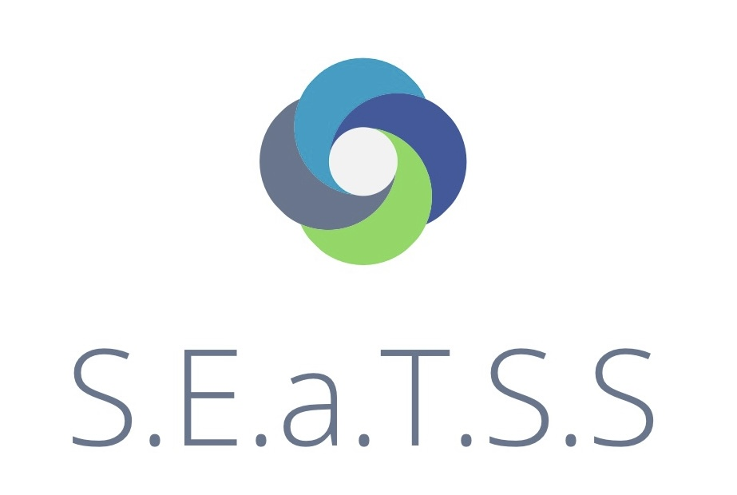
WRITING- STEPS TO STANDARDS

Students name:
School year
Actual age

The student can |  |  |  | Comments | Date
- show understanding that marks and symbols convey meaning e.g., place symbols on a timetable/ choice board

- make random contact with paper and shows little muscular control

- show awareness that their movements result in the marks on the paper.

- make marks that are random and go in many directions

- holds a mark maker in a palmar grip

- control scribbles and repeat on request

- produce meaningful marks or symbols associated with their own name or familiar spoken words

- draws large circles with mark-making tools

- demonstrate transition to holding mark maker between thumb and forefinger.

- form a variety of circles and lines

- form directional lines on request

- form a ‘x’

- use scissors to make snips in paper

- twists objects, for example to open a container

- use one hand consistently for most activities

- hold mark-making tools with three fingers in a tripod grip and makes marks with control

- draw using anticlockwise movements with mark making tools

- draw simple shapes with mark-making tools

- shape and moulds malleable materials using their hands, fingers and simple tools

- draw a picture and use symbols or marks to annotate key elements

- enjoy creating marks using different materials, such as paint and crayons

- give meaning to the marks they make when drawing, painting or writing

- use mark-making tools with control

- draws lines and circles using large scale movements

- say an appropriate word to complete a sentence when the adult pauses (e.g. ‘We’re going to the…zoo/park/shop/beach’)

- draw lines or shapes on a small or a large scale (e.g. on paper, or in the air, or sand)

